Michael Weaver

CST – 235

Brandon Bass

12/24/17

**CLC 7**

GitHub Link: https://github.com/battousairurik/CST-235

**CLC Questions**

1. ProgrammableWeb.com contains several API, or application programming interfaces, many of which operate the same way. One such program is the Unofficial Pokémon Go java API, which allow you to create your own interactive player portal for the Pokémon Go game.

***Pokemon Go API Location****: https://www.programmableweb.com/api/unofficial-pokemongo-java*

This package includes a GitHub link to the files for download and the API endpoint location for your designed application to link to. The files are located here:

***Pokémon Go GitHub Location****: https://github.com/Grover-c13/PokeGOAPI-Java*

The files include a ReadMe meant to describe how to install the folder and extract the data, but it is not detailed enough to actually work. Each of the provided files are structured to open a link to the Pokémon Go API then send or receive information over that open link. This is the way API function, so long as the data intending to be set is formatted correctly, the API will function. One such example is the CheckEvolutionExample.java which checks the current Pokémon id against the database to determine if there are any evolutions for the selected Pokémon.

**Assignment Approach**

1. For this assignment I researched what API are, then utilized the provided links on the API homepage to locate the GitHub documentation for the Pokémon Go API. The GitHub page contains instructions, albeit incomplete, on how to unpackage the PokeGOAPI-Java. The provided description is not detailed enough for someone with only a small amount of programming knowledge to unpackage and use:

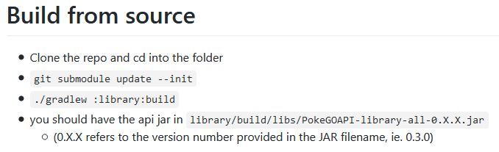

**List of Classes, Methods, Variables, etc.**

1. All public example code located in the GitHub link

**Screenshots**

Pokemon Go Evolution Check

